**Colorization of grayscale images using Vector Quantization**

Project – I Report

Submitted in Partial fulfillment of the requirements

For the degree of

BACHELOR OF ENGINEERING

BY

**Himanshu Avinash Jethawa**

**Jayesh Jagdish Kshirsagar**

**Jigar Dayaram Bhanushali**

Under the guidance of

**Mrs. Grishma Sharma**

DEPARTMENT OF COMPUTER ENGINEERING

K. J. SOMAIYA COLLEGE OF ENGINEERING, MUMBAI

UNIVERSITY OF MUMBAI

2011-2012

**Colorization of grayscale images using Vector Quantization**

Submitted by:

**Himanshu Avinash Jethawa**

**Jayesh Jagdish Kshirsagar**

**Jigar Dayaram Bhanushali**

Internal Guide Examiners

------------------------ --------------------

Mrs. Grishma Sharma

--------------------

-------------------------- ---------------------

Head of Department Principal

**TABLE OF CONTENTS**

|  |  |  |
| --- | --- | --- |
| CHAPTER | CONTENT | PAGE NO. |
| 1 | ABSTRACT | 4 |
| 2 | INTRODUCTION | 5 |
| 3 | AIMS AND OBJECTIVES | 6 |
| 4 | LITERATURE SURVEY | 7 |
| 5 | PROBLEM DEFINITION | 9 |
| 6 | PROPOSED SYSTEM | 10 |
| 7 | METHODOLOGY | 11 |
| 8 | ANALYSIS | 15 |
|  | 8.1. Software Project Management Plan |  |
|  | 8.2. Software Requirement Specification Document |  |
|  | 8.3. Software Design Document (All applicable UML diagrams) |  |
| 9 | HARDWARE AND SOFTWARE PLATFORM REQUIREMENTS, PROGRAMMING TOOLS | 22 |
| 10 | CURRENT STATUS OF THE PROFECT | 23 |
| 11 | IMPLEMENTATION PLAN FOR THE NEXT SEMESTER | 24 |

1. **Abstract**

Colorization is a computer-aided process of adding color to a grayscale image or video. The task of colorizing a grayscale image involves assigning three dimensional (RGB) pixel values to an image which varies along only one dimension (luminance or intensity). Since different colors may have the same luminance value but vary in hue or saturation, mapping between intensity and color is not unique, and colorization is ambiguous in nature, requiring some amount of human interaction or external information.

The project presents use of assorted window sizes and their impact on colorization of grayscale images using Vector Quantization (VQ) techniques. The problem of coloring grayscale image has no exact solution. Attempt is made to minimize the human efforts needed in manually coloring grayscale images. Here human interaction is only to find reference image of similar type. The job of transferring color from reference image to grayscale is done by proposed techniques. The attempt of using different VQ techniques helps us to identify the best result of colorization. Various VQ techniques are available like LBG, KPE, KFCG, etc. and out of all we try to find the best suitable approach for the image compression. According to survey we find it best for KFCG.

1. **Introduction**

Colorization is a computer aided process of adding colors to a grayscale image or videos. There was a time when all images were solely grayscale due to limitation in technology. Color images always provide more clear information than grayscale images. Coloring of old Black and White movies and rare images of monuments, celebrities is one of the interesting applications of colorization of gray scale images. The color details in the images can be utilized for analysis and study of particular image in the applications like medical tomography, information security, image segmentation, etc.

Many techniques have been proposed to perform the task of coloring grayscale image. But all of these techniques have inherent drawback of needing certain amount of human interaction such as selecting a color from color palette, choosing a seed pixel and segmenting the regions of image for colorization. The main purpose of this algorithm is to reduce human interaction and achieve the effect of colorization of grayscale images. All that is needed is a source image of similar feature as of input grayscale image to be colorized. Also the hindrance of needing source color image to be bigger than the target to be colored grayscale image is removed by use of Vector Quantization based on colorization process discussed here. Colors perceived in an object are determined.

1. **Aims and Objectives**

**Aim: -**

Aim of the project is to colour a given grayscale image by transferring the colour information of reference colour image.

**Objective: -**

Objective of program is to get the best quality in terms of colour and intensity, by minimize the computation cost.

* Input to the program will be a reference color image & target grayscale image.
* Output will be colored version of the grayscale image.
* The colorization will be performed with least human interaction and high quality.

1. **Literature Survey**

The project deals with the colorization of graysacale images. The steps involved in this project and their corresponding references are as follows:

1. Pre-processing which involves generating feature vector for the vector quantization step. First the reference color image is accepted from the use as input. This image is divided into blocks of mXn, where m and n are taken from user. Various mXn are 1X2, 2X2, etc.[6] The output of this step will be set of vectors of dimension mXnX3.
2. Vector Quantization: This is the very important step whose input is the feature vector generated in the preprocessing step. We consider two VQ algorithms.
3. Linde-Buzo-Gray Algorithm.

An efficient,and intuitive algorithm is presented for the design

of vector quantizers based either on a known prohabitistic model or on a long training sequence of data. Steps of this algorithm are listed in the methodology part of this report as well as in[8].

1. Fast Codebook Generation Algorithm.

This algorithm reduces the time of code book generation. Initially we have

one cluster with the entire training vectors and the code vector C1 which is centroid. In the first iteration of the algorithm, the clusters are formed by comparing first element of training vector with first element of code vector C1. The vector Xi is grouped into the cluster 1 if xi1< c11 otherwise vector Xi is grouped into cluster 2 . where code vector dimension space is 2. In second iteration, the cluster 1 is split into two by comparing second element xi2 of vector Xi belonging to cluster 1 with that of the second element of the code vector. Cluster 2 is split into two by comparing the second element xi2 of vector Xi belonging to cluster 2 with that of the second element of the code vector . This procedure is repeated till the codebook size is reached to the size specified by user. [6,4,7].

1. Colorization: From the VQ step we get codebook as the output, which is used for matching and colorization purpose. The target greyscale image is divided into pixel windows of size mXn . The closest match in the color palette is determined by calculating the Euclidean distance between average RGB of four values in color palette (Codebook) and greyscale pixel window values from the grey image. Once this closest match is found then colour information of these pixels is transferred to grayscale pixels. In the end of this step we get colorized version of target grayscale image.[6,4]
2. **Problem definition**

The purpose of project is to achieve best quality of colorization with least human interface.

The input from user is a grayscale image which is to be colored, and a reference image of similar color information. The operation of Vector Quantization is performed to compress the image and store the information with least memory usage. The algorithm matches the intensity level of target grayscale image with reference color image and accordingly color transfer is done from reference image to target image.

1. **Proposed System**

The steps of the algorithm are:

1. Input images

We input the image grey scale image to be colored and a reference image for the color transfer.

1. Vector Quantization

Used for the data compression i.e. mapping of k-dimensional vector space to finite set, i.e., codebook. Codebook refers to the mapping of the color pixels to the target grayscale image from the source color image.

Two algorithms are used separately, and their results are compared.

* LBG.
* Fast codebook generation.

1. Colorization

Transfer of the colors from source reference image to target image.

1. **Methodology**

**Colorization using Vector Quantization techniques**

The disadvantage of existing algorithms is more processing time and selectively good performance. To overcome these, following algorithm is developed. The main concepts related to algorithm are as follows.

**Vector quantization**

Vector Quantization is an efficient technique for data compression. VQ can be defined as the mapping function that maps k-dimensional vector space to the finite set CB = {C1, C2, C3,...,CN}. The set CB is called codebook consisting of N number of code-vectors and each code-vector, Ci = {ci1, ci2, ci3,……,cik} is of dimension k. The key to VQ is the good codebook.

1. **Vector Quantization using LBG algorithm:**

This algorithm can be given as follows:

1. Determine the number of code words, *N* or the size of the codebook.
2. Select *N* code words at random, and let that be the initial codebook. The initial code words can be randomly chosen from the set of input vectors.
3. Using the Euclidean distance measure clusterize the vectors around each codeword. This is done by taking each input vector and finding the Euclidean distance between it and each codeword.  The input vector belongs to the cluster of the codeword that yields the minimum distance.

This method is similar to our proposed approach but it has got a disadvantage that it uses Euclidean distance formula for finding the cluster. Thus, for every pixel, the distance is calculated which increases the cost.

1. **Fast codebook generation Algorithm**

Following are the steps:

1) Initially we have one cluster with the entire training vectors and the code vector C1 which is centroid.

2) In the first iteration of the algorithm, the clusters are formed by comparing first element of training vector with first element of code vector C1. The vector Xi is grouped into the cluster 1 if xi1< c11 otherwise vector Xi is grouped into cluster 2 as shown in Figure 1.a. where code vector dimension space is 2.

3) In second iteration, the cluster 1 is split into two by comparing second element xi2 of vector Xi belonging to cluster 1 with that of the second element of the code vector. Cluster 2 is split into two by comparing the second element xi2 of vector Xi belonging to cluster 2 with that of the second element of the code vector as shown in Figure 1.b.

4) This procedure is repeated till the codebook size is reached to the size specified by user.

It is observed that this algorithm gives less error as compared to LBG and requires least time to generate codebook as compared to other algorithms, as it does not require any computation of Euclidean distance. The algorithm shown in Figure 7.a and Figure 7.b for two dimensional case it is easily extended to higher dimensions.



Figure 7.a



Figure 7.b

**Colorization technique:**

The actual colorization is performed in two steps. Firstly the color palette is generated for source color image using codebook generation explained above. A color palette is nothing but compressed version of source image. The purpose of this step is to obtain this compression or color palette for later comparisons. Now it is clear that comparisons can be performed at faster rate. However, the color palette generated must be a perfect compression of source color image.

In the next step we have color palette and target image. Now we find match for every pixel of target image into color palette. Once the best match is obtained, the color info is transferred to target image. Following is the brief outline of these steps:

**A) Color palette generation using VQ.**

The steps generates color palette as the VQ codebook of source color image.

1) This source color image is divided into pixel windows of size mxn (each pixel consisting of red, green and blue components).

2) These are put in a row to get 3*m*n values per vector (as 4 sets of Y, Crg and Crb values in YCrgCrb color space or 4 sets of R, G and B values in RGB color space or 4 sets of red, green and blue values in RGB color space ). Collection of these vectors is a training set (initial cluster).

3) The LBG and Fast codebook generation algorithm are applied on this initial training set separately. And the results in each case are compared. .

The codebook obtained in this step serves as the color palette for rest of the program.

**B) Colorization.**

The target grayscale image is divided into pixel windows of size mXn. These 4 values are put into the row and are compared with GR component of all the code-vectors in RGB color space, with Y component of the all the code-vectors in YCrgCrb color space and with average of RGB for each of the four pixels of the code-vector in RGB color space.

The closest match in the color palette is determined by calculating the Euclidean distance between Y or Average RGB of four values in color palette (Codebook) and grayscale pixel window values from the grey image.

Then the color transfer is done from source pixel to target pixel.

1. **Analysis**

8.1. SOFTWARE PROJECT MANAGEMENT PLAN:

1. Introduction:

1.1 Project overview:

The purpose of this project is to colorize grayscale image with maximum efficiency and good quality.

1.2 Project deliverables:

1. SRS

2. Software project management plan

3. Software design document(data design, architectural design, interface design andprocedural design)

2. Project Organization:

2.1 Software Process Model:

Rapid prototyping:

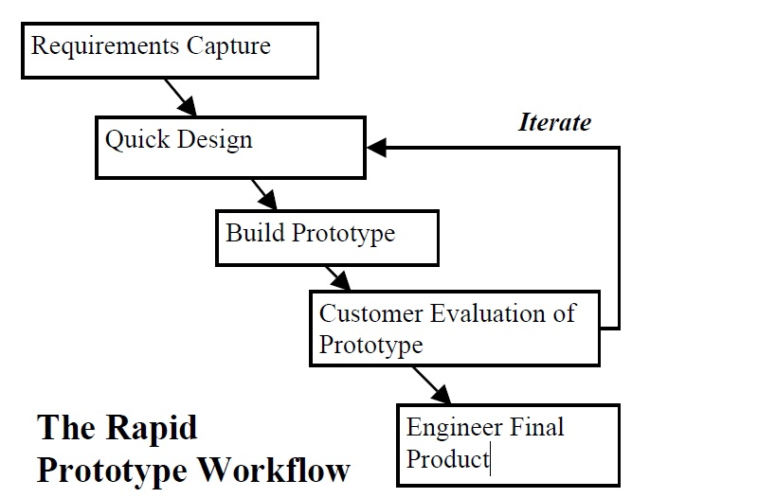

Figure1. Rapid Prototype Workflow

2.2 Roles and Responsibilities:

In order to complete the project successfully, the various tasks are assigned amongst the group members according to their ability. Each member should perform the given task efficiently.The members should give proper design for the code, based on which the functions have to beperformed:

Following table shows the roles and responsibilities of the each member:

|  |  |  |
| --- | --- | --- |
| Roles | Name | Responsibilities |
| Team Leader | Himanshu Jethawa | * Design generation * requirement gathering, * evaluation of codes. |
| Project Analyzer | Jayesh Kshirsagar | * Analysis. * Evaluation of code * Testing |
| Project Manager | Jigar Bhanushali | * Development of user interface. * Management of database. |

2.3 Tools and Techniques:

System requirements:

1. Software:

MATLAB 7.0 or later,

JAVA-JDK 1.6,

2) Hardware

RAM 512 MB,

16, 24 OR 32-bit OpenGL capable graphics adapter,

400 MB Disk Space.

3. Project management plan:

3.1 Assignments

|  |  |  |
| --- | --- | --- |
| Roles | Name | Responsibilities |
| Team Leader | Himanshu Jethawa | * Design generation * requirement gathering, * evaluation of codes. |
| Project Analyzer | Jayesh Kshirsagar | * Analysis. * Evaluation of code * Testing |
| Project Manager | Jigar Bhanushali | * Development of user interface. * Management of database. |

* 1. Timetable

|  |  |  |  |  |
| --- | --- | --- | --- | --- |
| Tasks | Description | Days allotted | Start Date | End Date |
| Requirement Gathering | Collection of information and literature survey. | 15 |  |  |
| Designing | Prototype using Matlab & Java | 15 |  |  |
| Coding | Building the Encoder, segmentor etc. and user interface | 45 |  |  |
| Testing | Testing various modules. | 30 |  |  |
| Documentation | Generating different reports. | 15 |  |  |

8.2 SOFTWARE REQUIREMENT SPECIFICATION DOCUMENT:

Purpose: Our purpose is to develop a software that will produce colourized version of a grayscale image. In general, the colourization requires lot of human interaction. Therefore, our objective will be to reduce human interaction as well as to produce high quality colourized image.One of the major applications of this software is during transmission of image over a network. At sender side, a colour image will be converted into grayscale image.This image will then be transmitted over a network. The receiver will colour this grayscale image and get the desired image. This process helps in reducing the bandwidth taken by the image during transmission.

Scope: The input to the application will be :

1. Reference colour image 2.A grayscale image which is to be colourized

The application we are designing is mainly divided in to two parts:

1st is to produce compressed version of colour information in the reference image.

2nd is to transfer this colour information to the grayscale image to produce it’s colourized version.

References: [http://www.mathworks.com](http://www.mathworks.com/)

Overall Description

8.2.1 Product Perspective

Our software will be used for colourizing a grayscale image.

8.2.1.1 System Interfaces

The system interfaces consist of matlab interface.

8.2.1.2 Hardware Interfaces

All components must be able to execute on a personal computer

8.2.2 Product functions

Functional requirement define a system’s capabilities and services. Functional requirements are frequently described using use case scenarios and formatted specifications

* The main function ofour software is to colourize a grayscale image.

8.2.3 Constraints

The reference colour image and the grayscale image must contain the similar colour information in order to produce realistic coloured image.

8.2.4 Performance requirement

For some vector quantization algorithms like LBG, the dimensions of the image must be within certain range as it takes much time to compress the image with large dimensions.

8.2.5 Software system attributes

Maintainability: System should be maintained and updates after every use for database updating and training of system.

Recoverability: Recovery steps have to be defined in case of system or database failures. For Database log based recovery is used.

8.2.6 Other requirements

No other specific requirements

8.3 SOFTWARE DESIGN DOCUMENT:

**Activity diagram**

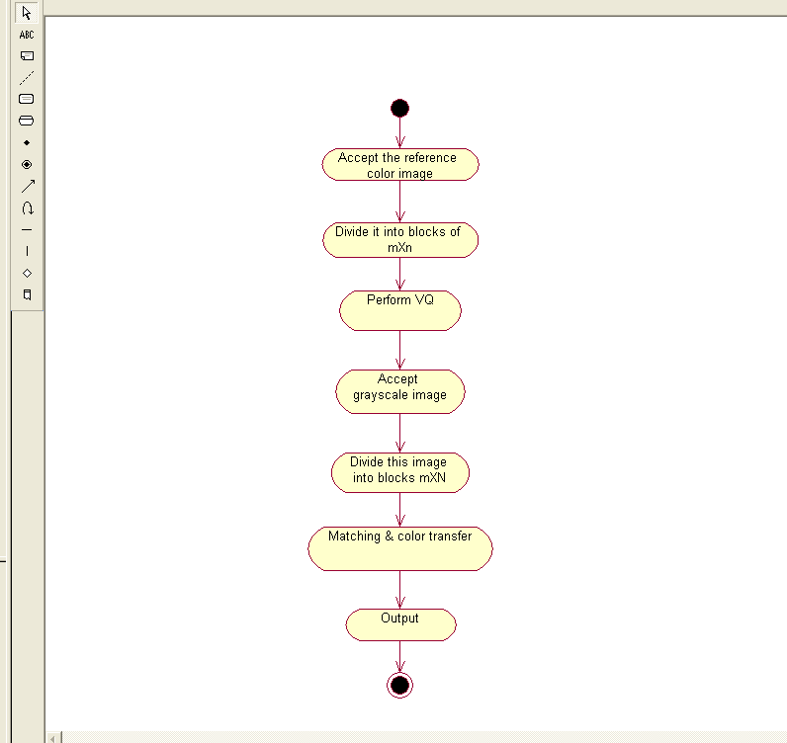

**Sequence diagram**

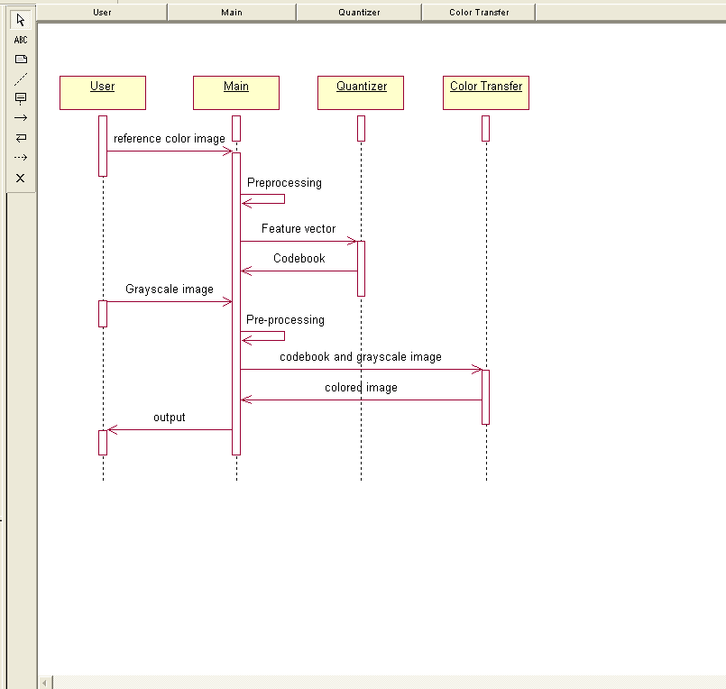

1. **Requirement Specification**

Software Requirements:

* Windows Xp or higher version (any Operating System supporting Matlab).
* Matlab 7.0 or higher version of it.

Hardware Requirements:

* RAM of 512 MB or higher for fast processing.
* Pentium-4 processor or higher versions.

1. **Current Status**

In this very interesting project, we have just crossed our starting steps. Out of three Vector Quantization algorithms to be implemented in this system, we have implemented first algorithm (LBG). Also we have implemented the general matching process and colorization. So at this stage, we have obtained some trivial results of colorization. So in the next semester remaining two algorithms will be implemented and performance will be more and more optimized.

1. **Implementation Details for Next Semester**

Next semester we have o do the second vector quantization technique i.e. Fast codebook generation method. We will do:

* Vector quantization using Fast Codebook Generation.
* Comparison of the results of LBG & FCG.
* Pre-processing (if required).
* Post-processing (if required).

1. **References**

**Papers:**

1. Dr. H. B. Kekre, Dr. Tanuja K. Sarode, Sudeep D. Thepade, Ms. Supriya Kamoji, “Analysing Assorted Window Sizes with LBG and KPE Codebook Generation Techniques for Grayscale Image Colorization”, *(IJCSIS) International Journal of Computer Science and Information Security, Vol. 9, No. 6 June 2011*

2. H. B. Kekre, Tanuja Sarode, Sudeep D. Thepade, Supriya Kamoji, ”Performance Comparison of Various Pixel Window Sizes for Colorization of Grayscale Images using LBG, KPE, KFCG and KEVR in Kekre’s LUV Color Space”,International Journal of Engineering and Advanced Technology (IJEAT) ISSN: 2249 – 8958, Volume-1, Issue-2, December 2011

3. Vivek George Jacob, Sumana Gupta” COLORIZATION OF GRAYSCALE IMAGES AND VIDEOS USING A SEMIAUTOMATIC

APPROACH”, *978-1-4244-5654-3/09/$26.00 ©2009 IEEE*

4.Yogesh Rathore, Avinash Dhole, Ramnivas Giri, Umesh Agrawal, “Colorization of Gray Scale Images using Fully Automated Approach”,*IJECT Vol. 1, Issue 1, December 2010, I S S N : 2 2 3 0 – 7 1 0 9 (Online)*

5. Liron Yatziv, Guillermo Sapiro, “Fast Image and Video Colorization Using Chrominance Blending”, *IEEE TRANSACTIONS ON IMAGE PROCESSING, VOL. 15, NO. 5, MAY 2006*

6. H. B. Kekere, Sudeep Thepade & Nikita Bhandari “Colorization of Greyscale Images Using Kekre’s Biorthogonal Color Spaces and Kekre’s Fast Codebook Generation”

7. H.B.Kekre, Sudeep Thepde, Tanuja Sarode, “Kekre’s Fast Codebook Generation in VQ with various Color Spaces for Colorization of grayscale Images”.

8. “An Algorithm for Vector Quantizer Design”yoseph linde, member. Ieee. Andres buzo, member, eee, **a m** robert **m.** Gray, senior member

**Websites:**

9. [http://www.mathworks.com](http://www.mathworks.com/)

This is the website of the developers of Matlab. This website helped us for understanding various basic inbuilt functions of matlab.

10. [http://www.wikipedia.com](http://www.wikipedia.com/)

This website was a source of various concepts' understanding in conjunction with the textbooks & websites.

11. <http://www.mathtools.net/MATLAB/>

This website lists various inbuilt functions and their applications. Also there are many video tutorials about matlab on this site.

**Books:**

1. ‘Introduction to Digital signal processing’ – John G. Proakis, D.G. Manolakis (Maxwell Macmillan Int.).
2. R. C.Gonsales R.E.Woods, “Digital Image Processing using Matlab”.